**Configurare manuala de tunele ipv6ip**

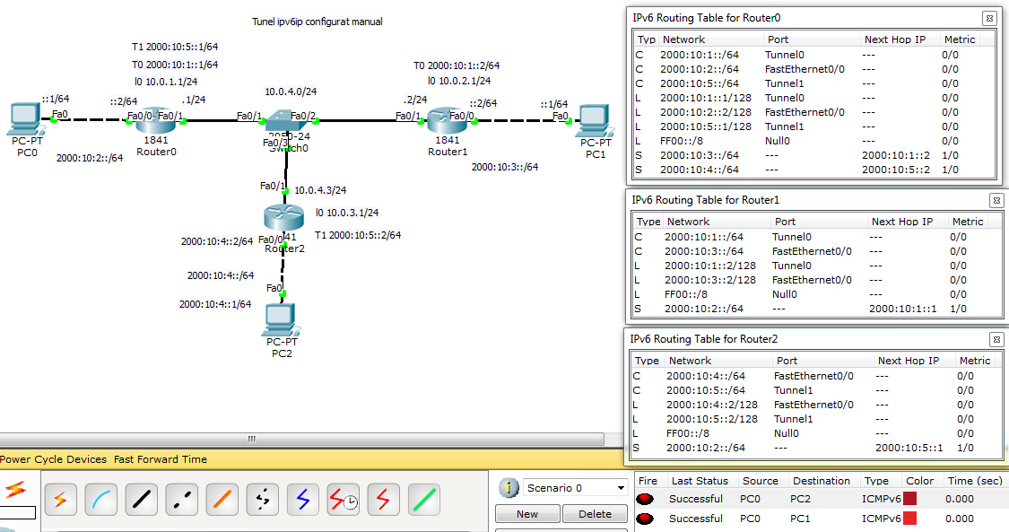

**Router0#sh run**

interface Loopback0

ip address 10.0.1.1 255.255.255.0

!

interface Tunnel0

no ip address

mtu 1476

ipv6 address 2000:10:1::1/64

ipv6 enable

tunnel source Loopback0

tunnel destination 10.0.2.1

tunnel mode ipv6ip

!

interface Tunnel1

no ip address

mtu 1476

ipv6 address 2000:10:5::1/64

ipv6 enable

tunnel source Loopback0

tunnel destination 10.0.3.1

tunnel mode ipv6ip

!

interface FastEthernet0/0

no ip address

duplex auto

speed auto

ipv6 address 2000:10:2::2/64

ipv6 enable

!

interface FastEthernet0/1

ip address 10.0.4.1 255.255.255.0

duplex auto

speed auto

!

interface Vlan1

no ip address

shutdown

!

ip classless

ip route 10.0.2.0 255.255.255.0 10.0.4.2

ip route 10.0.3.0 255.255.255.0 10.0.4.3

!

ipv6 route 2000:10:3::/64 2000:10:1::2

ipv6 route 2000:10:4::/64 2000:10:5::2

line con 0

!

**Router2#sh run**

!

interface Loopback0

ip address 10.0.3.1 255.255.255.0

!

interface Tunnel1

no ip address

mtu 1476

ipv6 address 2000:10:5::2/64

ipv6 enable

tunnel source Loopback0

tunnel destination 10.0.1.1

tunnel mode ipv6ip

!

interface FastEthernet0/0

no ip address

duplex auto

speed auto

ipv6 address 2000:10:4::2/64

ipv6 enable

!

interface FastEthernet0/1

ip address 10.0.4.3 255.255.255.0

duplex auto

speed auto

!

interface Vlan1

no ip address

shutdown

!

ip classless

ip route 10.0.1.0 255.255.255.0 10.0.4.1

!

ipv6 route 2000:10:2::/64 2000:10:5: